Fcuntional Component Example

Create a new file with the name of FunctionalComponent.jsx

import React from 'react';

import ReactDOM from 'react-dom';

//function 1

    function Header() {

      return <div>

        <h1>Welcome to REact Learning

</h1>

      </div>

    }

//function 2

    function Center(){

      return <div>

        <h2>React JS</h2>

        <h2>Java</h2>

        <h2>Python</h2>

        <h2>Node JS</h2>

      </div>

    }

//function 3

    function Footer(){

      return <div>

        <h1>Contact Us</h1>

        <h1>About Us</h1>

      </div>

    }

//function 4 Nested Element

    function Mywebsite()

    {

      return <div>

        <Header />

        <Center />

        <Footer />

      </div>

    }

    Export default Mywebsite;

Goto App.Js File

import Mywebsite from './new/FunctionalComponent';

class App extends Component

{

  render(){

    return (<div>

      <Mywebsite />

      <Mynewwebsite />

      }

     </div>

    )

  }

}

Class Component

classComponent.js

import React from 'react';

import ReactDOM from 'react-dom';

//class Component

class Mywebsite extends React.Component

{

  render()

  {

    return <h1>Welcome</h1>

  }

}

//class component using another class Component as tag

export default class Mynewwebsite extends React.Component

{

  render()

  {

    return <div>

      <Mywebsite />

      <h1>Thanks For Watching</h1>

    </div>

  }

}

App.Js

import logo from './logo.svg';

import './App.css';

import { Component } from 'react';

import Mywebsite from './new/FunctionalComponent';

import Mynewwebsite from './new/ClassComponent';

class App extends Component

{

  render(){

    return (<div>

      <Mywebsite />

      <Mynewwebsite />

      </div>

      )

  }

}

export default App;

in the above example both the class component is present in same File. Now let us split the classes into 2 different files and see how to call it.

ExternalComponent.js

import React from 'react';

import ReactDOM from 'react-dom';

class Mywebsite extends React.Component

{

  render()

  {

    return <h1>Welcome to REact Learning</h1>

  }

}

export default Mywebsite;

MainComponent.js

import React from 'react';

import ReactDOM from 'react-dom';

import Mywebsite from '../new/ExternalComponent';

export default class Mynewwebsite extends React.Component

{

  render()

  {

    return <div>

      <Mywebsite />

      <h1>Thanks For Watching</h1>

    </div>

  }

}

App.Js

import logo from './logo.svg';

import './App.css';

import { Component } from 'react';

import Mywebsite from './new/FunctionalComponent';

import Mynewwebsite from './new/ClassComponent';

import Mynewwebsite2 from './new/MainComponent';

class App extends Component

{

  render(){

    return (<div>

      {/\* <Mywebsite /> \*/}

      <Mynewwebsite2 />

      </div>

      )

  }

}

export default App;

FunctionalComponent.jsx

import { render } from "@testing-library/react";

import React from "react";

function Header1()

{

    var header={

        background:'blueviolet',

        height:'100px',

        widht:'100%',

        padding: '5px',

        color:'white'

    }

    return (

    <div style={header}><h1> <center>Nested Component Example</center> </h1>

    </div>)

}

function Center()

{

    var main={

        background:'sandal',

        height:'500px',

        widht:'100%',

        padding: '5px',

        color:'black'

    }

    return <div style={main}>

        <ul>

            <h2>List of Courses we laearn</h2>

            <li>C#.NEt</li>

            <li>MS SQL SERVER</li>

            <li> Web API</li>

            <li>React</li>

        </ul>

    </div>

}

function Footer()

{var footer={

    background:'blueviolet',

    height:'30px',

    widht:'100%',

    padding: '5px',

    color:'white'

}

    return <div style={footer}><span> <center>This is @2022</center></span></div>

}

export default function WebPage1()

{

    return <div>

        <Header1 />

        <Center />

        <Footer />

    </div>

}

//export default WebPage1;

App.Jsx

import logo from './logo.svg';

import './App.css';

import FunctionalComponent from './Components/demo';

import WebPage1 from './Components/FunctionalComponent';

function App() {

   return(

  <WebPage1 />

  )

}

export default App;

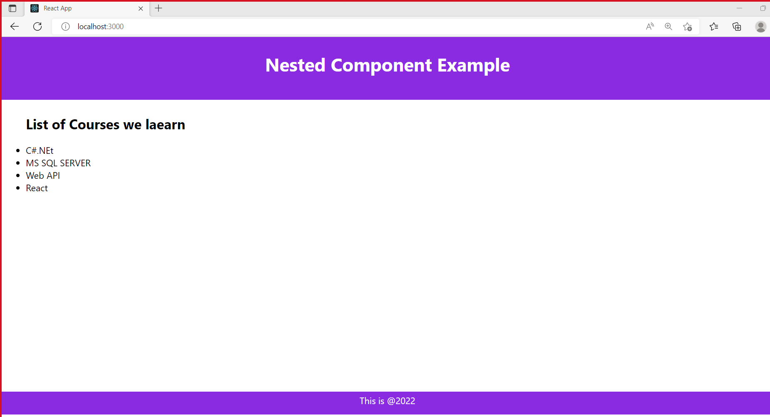

Suppose you need to devide each function as different Component we can split and reuse according to the need

Footer1.jsx

We are going put the function Footer() code in Footer1 and import Footer1 in WebPage

Below is the Example.

Footer1.jsx

import React from "react";

export default function Footer1()

{

    var footer={

        background:'blueviolet',

        height:'30px',

        widht:'100%',

        padding: '5px',

        color:'white'

    }

        return <div style={footer}><span> <center>This is @2022</center></span></div>

    }

FunctionalComponent.jsx

import { render } from "@testing-library/react";

import React from "react";

 import Footer1 from "./Footer1";

function Header1()

{

    var header={

        background:'blueviolet',

        height:'100px',

        widht:'100%',

        padding: '5px',

        color:'white'

    }

    return (

    <div style={header}><h1> <center>Nested Component Example</center> </h1>

    </div>)

}

function Center()

{

    var main={

        background:'sandal',

        height:'500px',

        widht:'100%',

        padding: '5px',

        color:'black'

    }

    return <div style={main}>

        <ul>

            <h2>List of Courses we laearn</h2>

            <li>C#.NEt</li>

            <li>MS SQL SERVER</li>

            <li> Web API</li>

            <li>React</li>

        </ul>

    </div>

}

export default function WebPage1()

{

    return <div>

        <Header1 />

        <Center />

        <Footer1 />

    </div>

}

We will get the same output as previous execution.

(we split the functional component in different File)

